**DAILY ONLINE ACTIVITIES SUMMARY**

|  |  |  |  |  |  |  |  |  |
| --- | --- | --- | --- | --- | --- | --- | --- | --- |
| **Date:** | **01/07/2020** | | | | | **Name:** | **NIKHIL KUMAR** | |
| **Sem & Sec** | **4thSEM. & ‘B’ SEC.** | | | | | **USN:** | **4AL19CS400** | |
| **Online Test Summary** | | | | | | | | |
| **Subject** | | **NULL** | | | | | | |
| **Max. Marks** | | **30** | | **Score** | | |  | |
| **Certification Course Summary** | | | | | | | | |
| **Course** | **Built your own chatbot** | | | | | | | |
| **Certificate Provider** | | | **Cognitiveclass** | | **Duration** | | | **5hr** |
| **Coding Challenges** | | | | | | | | |
| **Problem Statement1 :**  Given two lists, sort the values of one list using the second list.  Examples: Input : list1 = ["a", "b", "c", "d", "e", "f", "g", "h", "i"] list2 = [ 0, 1, 1, 0, 1, 2, 2, 0, 1] Output : ['a', 'd', 'h', 'b', 'c', 'e', 'i', 'f', 'g'] Input : list1 = ["g", "e", "e", "k", "s", "f", "o", "r", "g", "e", "e", "k", "s"] list2 = [ 0, 1, 1, 0, 1, 2, 2, 0, 1] Output : ['g', 'k', 'r', 'e', 'e', 'g', 's', 'f', 'o'] | | | | | | | | |
| **Status: Executed** | | | | | | | | |
| **Uploaded the report in Github** | | | | | **Yes** | | | |
| **If yes Repository name** | | | | | 1. <https://github.com/Nikhil401/C-Coding/blob/master/sort_value.py> | | | |
| **Uploaded the report in slack** | | | | | **Yes** | | | |

**Online Test Summary : Not conducted**

**Certification Course Summary: Today I have taken another certification course “Built your own chatbot” and I went through the module1 which includes “introduction to chatbots, chatbots are trending, Leader in the industry, lab1 with the quiz”**

**Snapshot is given below** 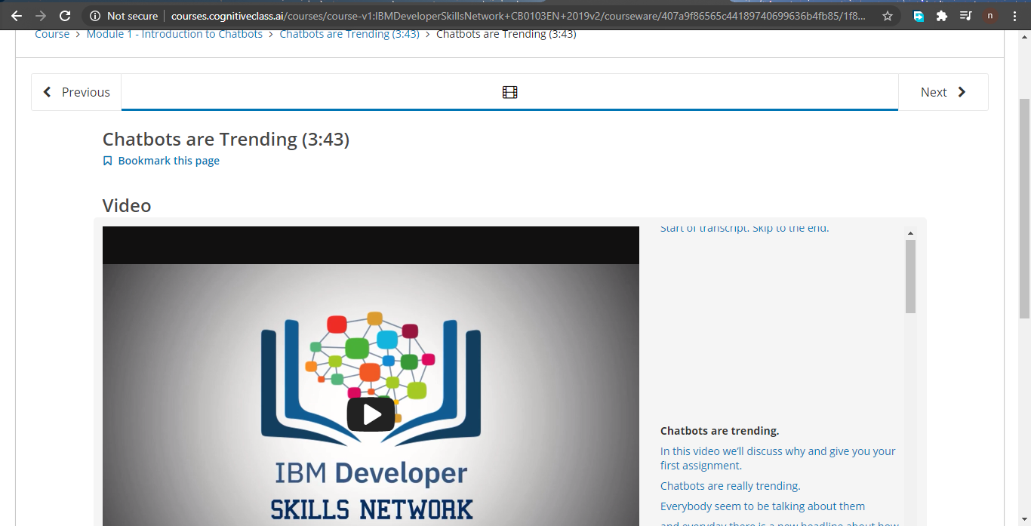

**Online Training : Instead of Online training there was webinar “GSU Webinar”**

**Snapshot is given below :** 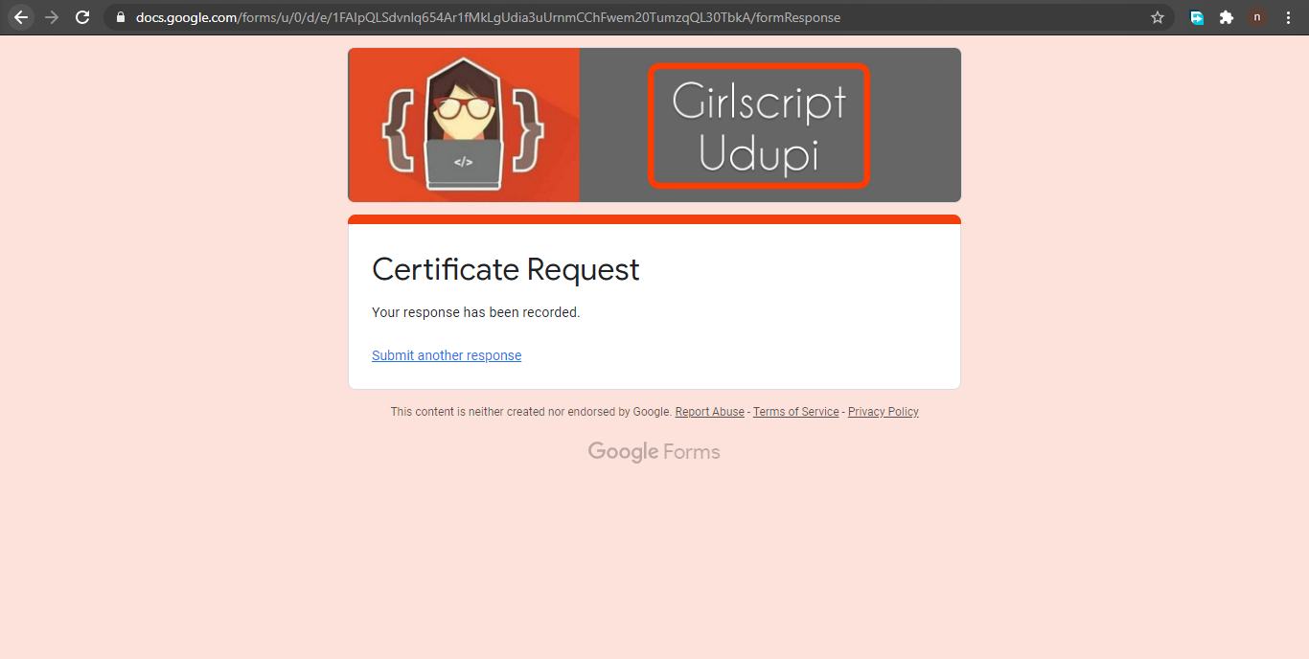

**Online coding summary: Today I had received programs which is mentioned in table above and I have uploaded into the github repository. Snapshot of the program is given below:**

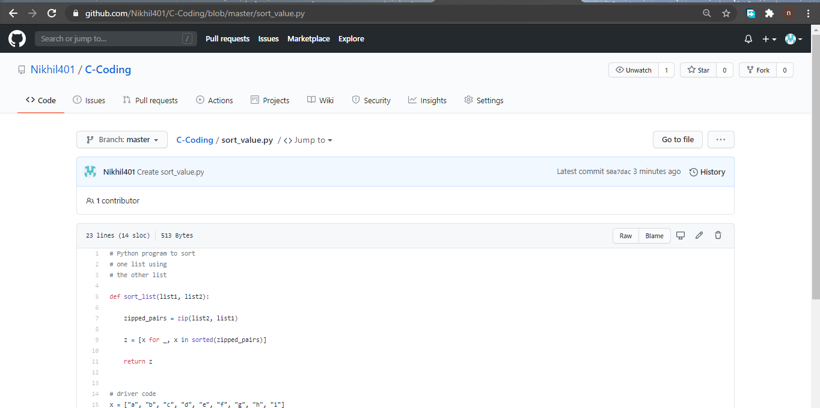 **Thank you.**